Summer 2022

Dear Year 2 parents and carers

On behalf of Cleves’ trustees, I am pleased to welcome you and your child to the Cleves’ community.

Cleves’ trustees’ ambition is for Cleves to be a forward-looking school that aims for high standards academically; that offers children the broadest possible range of educational and developmental experiences, and that provides support for the whole child – a place where every child can be happy and progress to the limits of his or her abilities and interests.

In the run up to the summer break we know that our school staff are working hard to make transition as smooth as possible so that every child can have the best possible start to their time at Cleves. Whether you already have a child or children at Cleves or are totally new to the school, we hope that you too will get off to a good start and that you will enjoy seeing your child thrive here. There will also be opportunities for you to become involved in supporting your child and the school, whether through joining our active PTA or in a range of other ways, and we would encourage you to do so.

I will not go into detail about Cleves’ governance here, but will just briefly say that trustees’ role is primarily about setting the strategic direction for the school and then ensuring that the school is on track. Behind the scenes we decide how to allocate the budget and monitor it; we monitor children’s performance and the school’s provision for safety and well-being, and we determine the school’s admissions policy – to name just a few of our varied responsibilities. At all times we work closely with our headteacher, Mr Hodges, and the leadership team, but we leave al of the day-to-day management of the school and operational issues to them. Several of our trustees are parents of current or former pupils and every so often we have a vacancy for a parent trustee. If you would like to know more about Cleves’ trustees and how we operate then please do take a look at the trustees’ section of Cleves’ website. And if you have any governance questions or are interested in being a trustee, then please contact me at chair@cleves.co.uk.

Meanwhile, I would like to wish you and your child a relaxing summer ready for an excellent start to Cleves in September.

With very best wishes

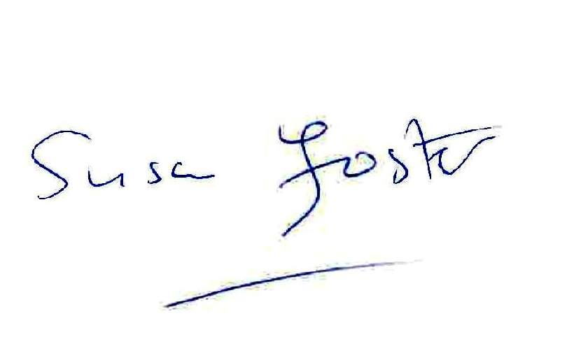
Susan Foster
Chair of Trustees

