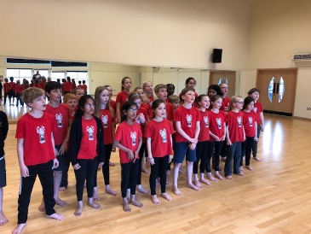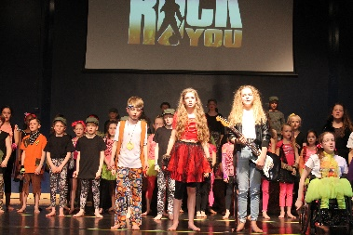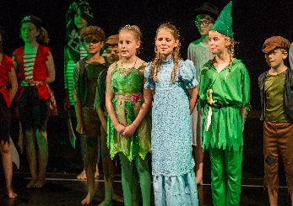  Dear Parent/Carer,  Theatre Works are proud to host drama classes at Cleves School, and in September we are looking forward to welcoming new students to our acting group.  During the term we will cover exciting topics in our drama sessions. The variety in our classes keeps children focused and enthused and after their stimulating classes they are alert and stretched mentally and physically. For the budding performers we can help them in all aspects of performance work and for all our students we aim to increase the confidence levels which will show in their school and social life. Most of all at Theatre Works we have fun through creative learning.  Over the autumn term we will be working with the children in various areas of the performing arts including musical theatre, scripted material/plays, creative writing, and presenting. (For more information look at our website www.theatreworks.biz)  Autumn term 2025:  Tuesdays- year groups 4,5 and 6 From 3.30pm until 4.30pm  Dates: Tuesday 9th September until 9th of December (13 x week term).  Our Theatre Works sessions take place in the performance hall.  Fees for the autumn term £125.00  To book a place please visit our website www.theatreworks.biz and head to the classes page where you will see the Cleves Tuesday group. Once you have enrolled you will receive an email confirming your child’s place.  Our drama group at Cleves is a wonderful one, filled with creative, happy and positive students. We look forward to welcoming the returning pupils and new students in year groups 4,5 and 6 who wish to join us in September.  For more information email jo@theatreworks.biz or call 07770 375344  Best wishes.  Jo  Principal Theatre Works  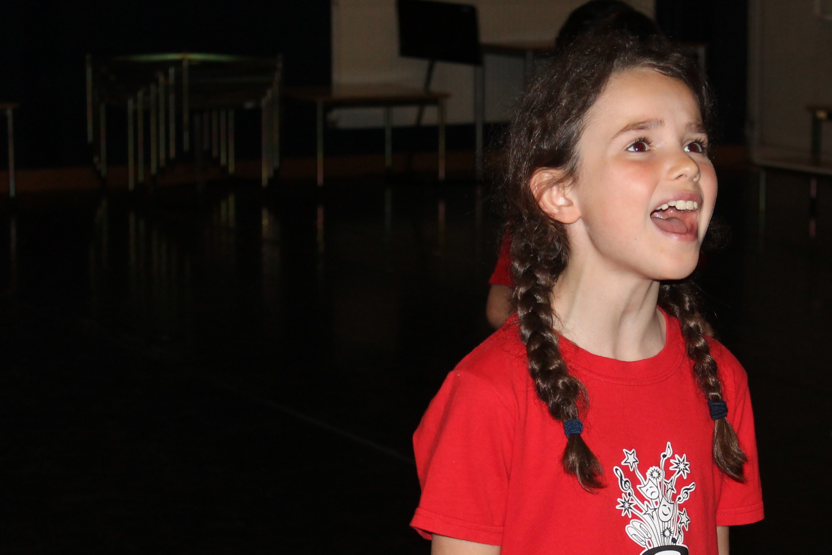 | Theatre Works  Drama classes at  Cleves School  Join us for our autumn term 2025.  Learn new skills in our exciting acting classes.  