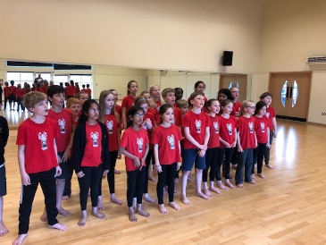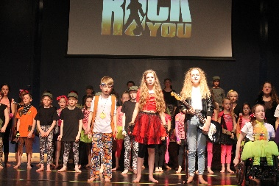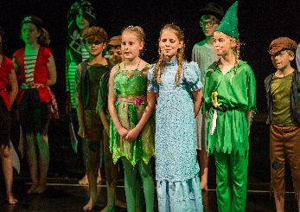  Dear Parent/Carer,  Theatre Works are proud to host drama classes at Cleves School, where we have been teaching acting and musical theatre classes for the past 13 years.  During the term we will cover exciting topics in our drama sessions. The variety in our classes keeps children focused and enthused and after their stimulating classes they are alert and stretched mentally and physically. For the budding performers we can help them in all aspects of performance work and for all our students we aim to increase the confidence levels which will show in their school and social life. Most of all at Theatre Works we have fun through creative learning.  Over the spring term we will be working on our show. The show will take place at Cleves school on Saturday the 14th of March.  If your child would prefer not to be participate in the performance, then they may choose to enroll for our skills term in the summer.  Spring term 2026:  Mondays- year groups 3 and 4 From 3.30pm until 4.30pm  Dates: Monday 12th Jan until 23rd of March.  Show date: Saturday the 14th of March 2026  Our Theatre Works lessons take place in the dance studio  Fees for the spring term are £105.00  To book a place please visit our website www.theatreworks.biz and head to the classes page where you will see the Cleves Monday group. Once you have enrolled you will receive an email confirming your child’s place.  Our drama group at Cleves is a wonderful one, filled with creative, happy and positive students.  If our website states that there are no spaces available please email jo@theatreworks.biz so that your child can be added to the waiting list.  For more information email jo@theatreworks.biz or call 07770 375344  Best wishes.  Jo  Principal Theatre Works  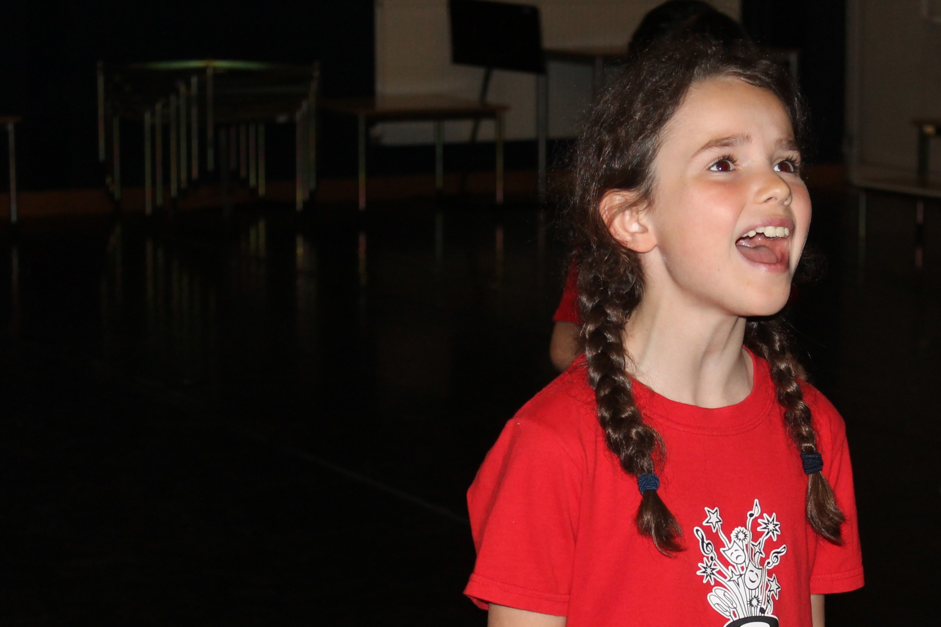 | Theatre Works  Drama classes at  Cleves School  Join us for our spring term 2026.  Learn new skills in our exciting acting classes.  