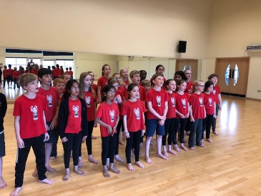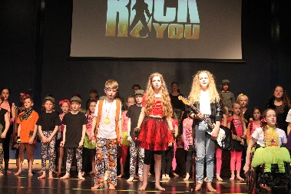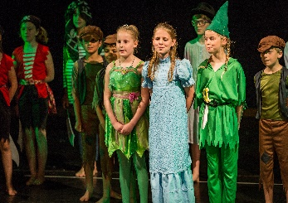  Dear Parent/Carer,  Theatre Works are proud to host drama and musical theatre classes at Cleves School.  During the term we will cover exciting topics in our drama sessions. The variety in our classes keeps children focused, enthused and after their stimulating classes they are alert and stretched mentally and physically. For the budding performer we can help them in all aspects of performance work and for other children we aim to increase confidence levels which will show in their school and social life. Most of all at Theatre Works we have fun through creative learning.  The autumn term is our skills term, where we will be covering lots of areas of acting and performing arts. (Our show term is the spring term and for more information about our sessions please look at our website www.theatreworks.biz).  Dates and classes for our autumn term 2023:  Tuesdays: Year groups 5 and 6 - 3.30pm until 4.30pm.  Dates: Tuesday the 12th of September until the Tuesday the 28th of November 2023. Our term is 11 x weeks in total fees are £105.00 for the full term. Our classes take place in the performance hall.  To book a place please visit our website www.theatreworks.biz and head to the classes page where you will see Cleves Tuesday class. Once you have enrolled you will receive an email confirming your child’s place.  Places are limited and booked on a first come first serve basis.  Our drama group at Cleves is a wonderful one, filled with happy and positive students. We look forward to welcoming new pupils for our autumn term 2023. For more information email jo@theatreworks.biz or call 07770 375344  Jo Russ  Principal Theatre Works | Theatre Works  Drama classes at  Cleves School  Enrolling now for our autumn term.  Learn new skills in our exciting acting classes.  